**Title: Installing the Apache server in AWS Linux machine**

1. Installing the tomcat in linux machine

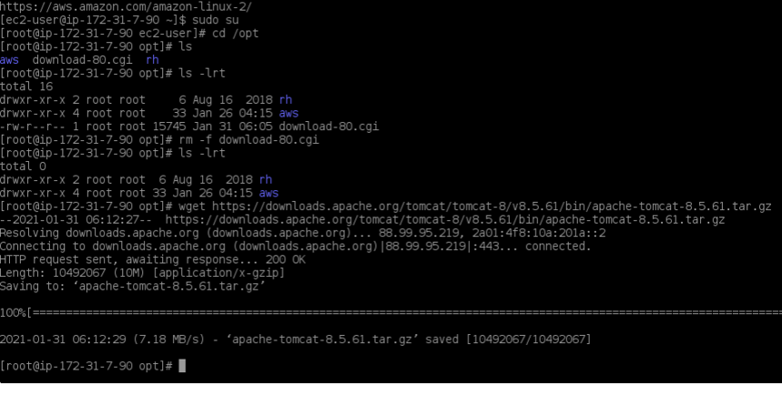

1. Unarchive the tar file in server

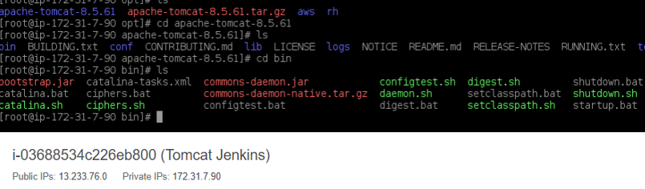

1. Changing the permissions of the services

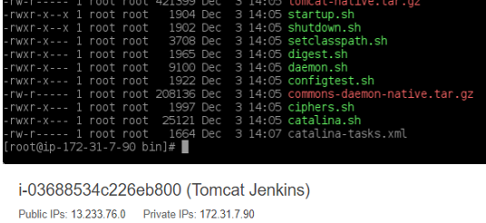

1. Creating the soft link for services

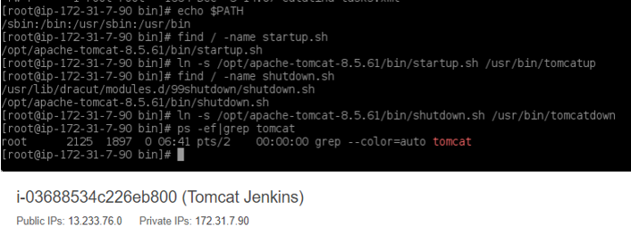

1. Changing the port to 8090

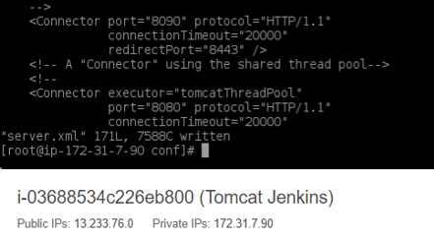

1. Tomcat webpage appeared after performing the stop and start the server.

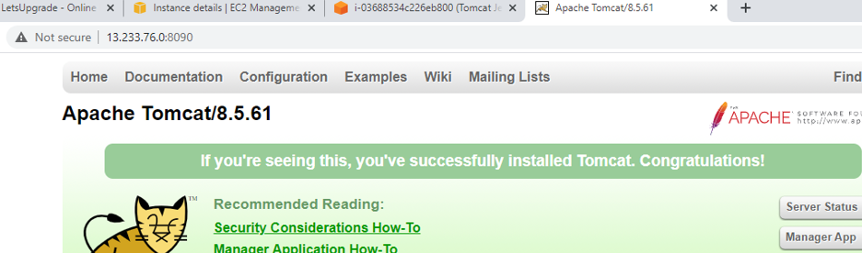

1. Added the users and roles and performed the stop and start

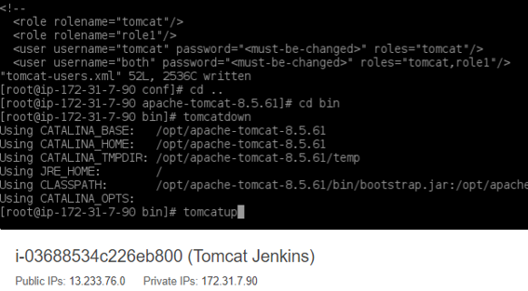

1. Web application manager page appeared after performed the stop and start the server.

